***FACE***

***RECOGNITION:***

***Using python programming and openCV***

***Module…***

***>>What is Recognition?***

Identification of someone or something or person from previous encounters or knowledge.

Similarly it is like *“IDENTIFICATION”.*

***>>What is Face or Facial Recognition?***

Facial recognition is a way of identifying or confirming an individual’s identity using their face. Facial recognition systems can be used to identify people in photos, videos, or in real-time.

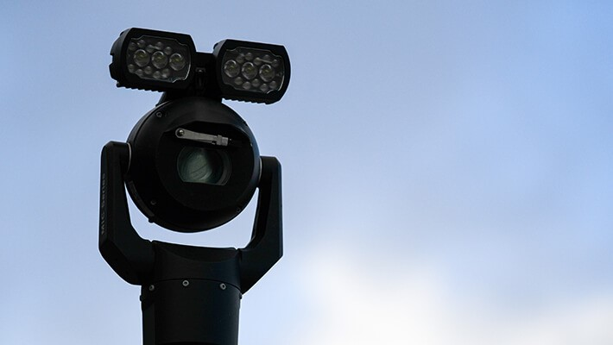

Facial recognition is a category of [***biometric security***](https://www.kaspersky.com/resource-center/definitions/biometrics)***.*** Other forms of biometric software include voice recognition, fingerprint recognition, and eye retina or iris recognition. The technology is mostly used for security and law enforcement, though there is increasing interest in other areas of use.

***>>And How it recognize the face?***

By using the Haarcascade files through reference from the GitHub

([Haar Cascade – GitHub).](https://github.com/opencv/opencv/tree/master/data/haarcascades)

In listed haarcascade files we should download the face related haarcascade file (haarcascade_frontalface_default.xml).

The above haarcascade file is used to recognition the faces in live Camera, videos and photos.

***>>Modules:***

* OpenCV – Python
* Numpy

***OpenCV:***

OpenCV is a Python library that allows you to perform image processing and computer vision tasks. It provides a wide range of features, including object detection, face recognition, and tracking.

***What is OpenCV?***

Gary Bradsky invented OpenCV in 1999 and soon the first release came in 2000. This library is based on optimised C / C++ and supports Java and Python along with C++ through an interface.

OpenCV is an open-source software library for computer vision and machine learning. The OpenCV full form is Open Source Computer Vision Library. It was created to provide a shared infrastructure for applications for computer vision and to speed up the use of machine perception in consumer products. OpenCV, as a BSD-licensed software, makes it simple for companies to use and change the code. There are some predefined packages and libraries that make our life simple and OpenCV is one of them.

***OpenCV installation :***

There are many ways in which you can install Opencv on your computer.

***Install using Anaconda***

conda install -c conda-forge opencv

After this command is successfully executed, OpenCV will be available on your computer.

***For Windows***

pip install opencv-python

After installing it,do check if it is installed successfully.For that just go to the command prompt and type ‘python’ and hit enter.You should see some message like this:

If this is not the message you see, I suggest reinstalling python into your system. Next type import cv2 and if there is no error then it is installed successfully.

***For Mac***

You can use homebrew to install OpenCV as it makes it really easy and you just have to use this command for installing:

brew install opencv

Now that you have installed the OpenCV onto your system, let’s see how it works.

***Read & Save Images***

Now for OpenCV to work on any image, it must be able to read it. Here we will see how to read a file and save it after we are done with it. Let’s see how to do it:

Two function are there in OpenCV Module to read image and save image.

1. Imread function
2. Imwrite function

**Imread function in OpenCV :**

Syntax:

cv2.imread(path,flag)

Ex:

#importing the opencv module

import cv2

img = cv2.imread(‘dog.jpg’,1)

#1 denotes read as color img

cv2.imshow(‘IMAGE’,img)

cv2.waitKey( )

# it is necessary to be required so that the image

doesn’t close immediately.

cv2.destroyAllWindows( )

Output:

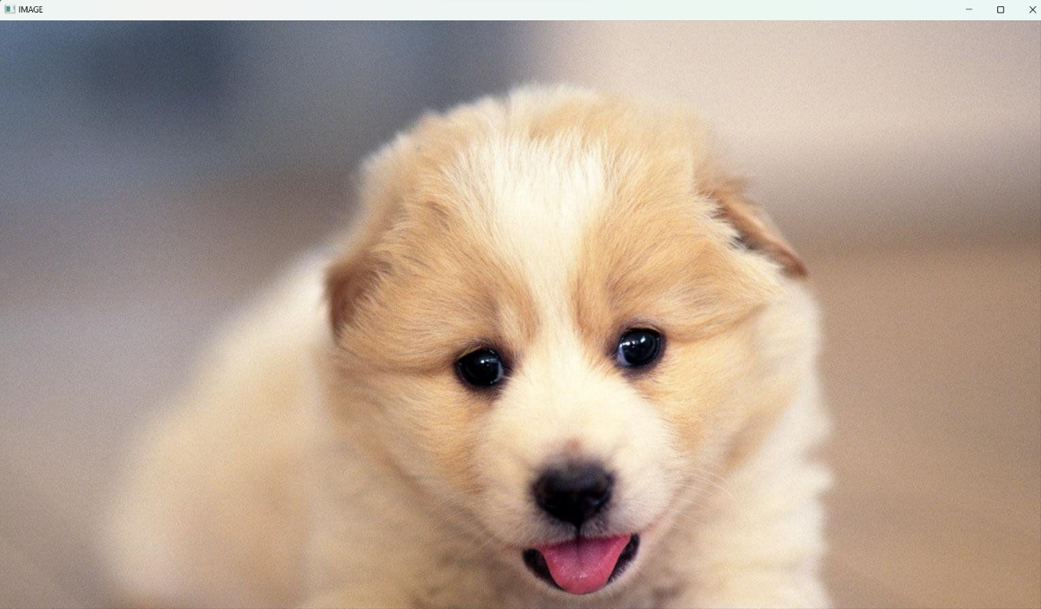

**Imwrite function in OpenCV :**

We can use OpenCV’s imwrite() function to save an image in a storage device and the file extension defines the image format as shown in the example below. The syntax is the following:

Syntax :

cv2.imwrite(filename,img)

Parameters:

filename: A string representing the file name. The filename must include image format.

image: It is the image that is to be saved.

Ex:

import cv2

img = cv2.imread(r’c:\Users\nithin\dog.jpg’,1)

save = cv2.imwrite(r’c:\Users\nithin\dog.jpg’,img)

print(“Image written success? : “,save)

Output:

Image written success? : True

***NumPy:***

NumPy is a Python library used for working with arrays.

It also has functions for working in domain of linear algebra, fourier transform, and matrices.

NumPy was created in 2005 by Travis Oliphant. It is an open source project and you can use it freely.

NumPy stands for Numerical Python.

***What is NumPy?***

NumPy is the fundamental package for scientific computing in Python. It is a Python library that provides a multidimensional array object, various derived objects (such as masked arrays and matrices), and an assortment of routines for fast operations on arrays, including mathematical, logical, shape manipulation, sorting, selecting, I/O, discrete Fourier transforms, basic linear algebra, basic statistical operations, random simulation and much more.

***Image Recognition Program:***

Program:

import cv2

import numpy as np

face_cascade = cv2.CascadeClassifier('haarcascade_frontalface_default.xml')

img=cv2.imread('img2.jpg')

gray_img = cv2.cvtColor(img,cv2.COLOR_BGR2GRAY)

face_rect = face_cascade.detectMultiScale(gray_img,1.1,5)

for (x,y,w,h) in face_rect:

    cv2.rectangle(img,(x,y),(x+w,y+h),(0,255,0),2)

cv2.imshow('IMAGE',img)

cv2.waitKey(0)

cv2.destroyAllWindows()

Output:

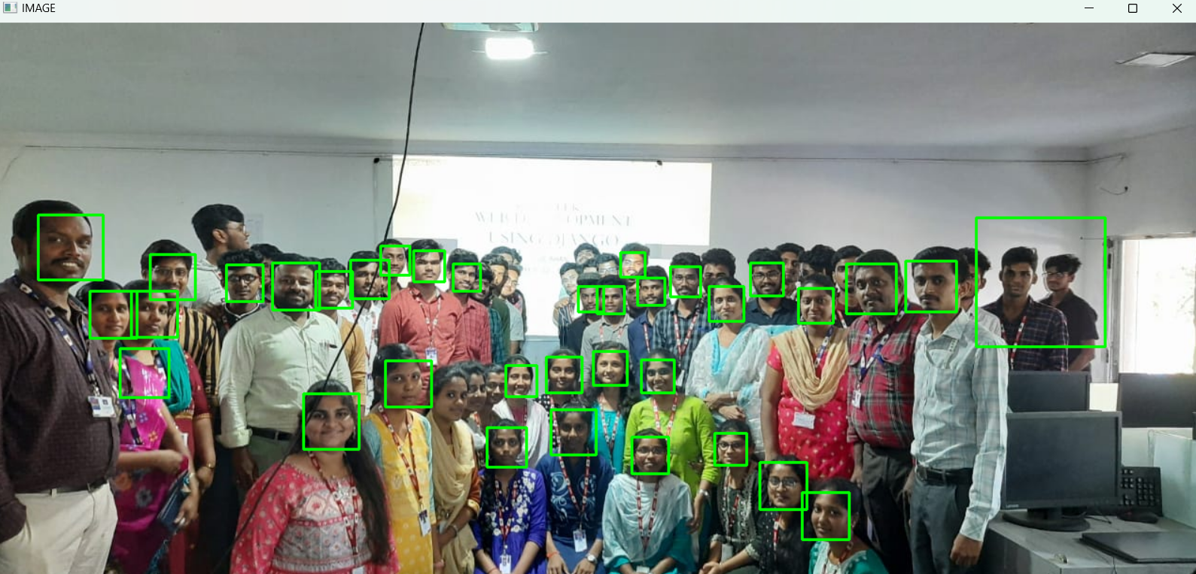

***Video Recognition Program:***

Program:

import cv2

import numpy as np

face_cascade = cv2.CascadeClassifier('haarcascade_frontalface_default.xml')

cap = cv2.VideoCapture('vid1.mp4')

while cap.isOpened():

    re,img = cap.read()

    gray_img = cv2.cvtColor(img,cv2.COLOR_BGR2GRAY)

    face_rect = face_cascade.detectMultiScale(gray_img,1.1)

    for (x,y,w,h) in face_rect:

        cv2.rectangle(img,(x,y),(x+w,y+h),(0,255,0),2)

        cv2.imshow('DETECTED FACE',img)

        #cv2.waitKey(0)

    if cv2.waitKey(1)  == ord('q'):

        break

cap.release()

cv2.destroyAllWindows()

Output:

***Live Camera recognition:***

Program:

import cv2

import numpy as np

face_cascade = cv2.CascadeClassifier('haarcascade_frontalface_default.xml')

cap = cv2.VideoCapture(0)

while cap.isOpened():

    re,img = cap.read()

    gray_img = cv2.cvtColor(img,cv2.COLOR_BGR2GRAY)

    face_rect = face_cascade.detectMultiScale(gray_img,1.1)

    for (x,y,w,h) in face_rect:

        cv2.rectangle(img,(x,y),(x+w,y+h),(0,255,0),2)

        cv2.imshow('DETECTED FACE',img)

        #cv2.waitKey(0)

    if cv2.waitKey(1)  == ord('q'):

        break

cap.release()

cv2.destroyAllWindows()

Output:

